**COMP231-S62G3**

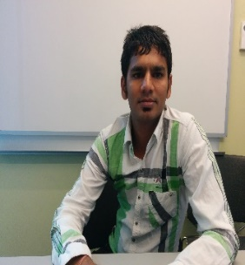 Vipul Patel(Scrum Master)

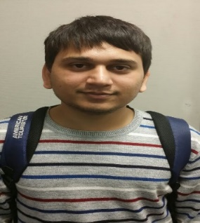 Parimal Patel (Developer)

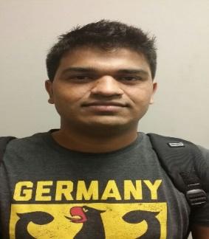 Bijal Patel (Developer)

 Heli Parekh (Developer)

 Nazneen Jahan (Developer)